# H1-IT World Technologies-H1

## H2- Website Design and Digital Marketing Services Company in Noida Delhi India- H2

**A professional and attractive looking website is a basic need for any successful business in today’s world. To get an attractive and interactive website for your website, you will need to hire one of the best website design company in Noida. A professional web designing company will deliver the exact website that you desire. But it’s not that easy to find the best company which will deliver the website exactly as you require.**

**IT World Technologies is ranked as the #1 Website design and development in Noida India because we are always available for our client’s help and provide them with premium quality services. The only aim to have a website for your business is to break the distance boundaries and attract potential clients. Therefore, none of the business owners or entrepreneurs is deprived of a website for their business. Well, having a ‘call-to-action button’ on your website brings you closer to the potential customers. With this idea in mind, you can create an easy option for your customers to reach out to you. This means that your clients don’t bounce back from your website. Apart from having a website, it is very important for you to make an appropriate marketing strategy by which your customers can easily search you online. It takes a lot of experience to design one marketing strategy which will pull out the high conversion rate for you. To get it done, you will need professional digital marketing services in Delhi NCR. Also, if your website does not get adjusted with different screen sizes and resolutions then you need to contact the best responsive website design company in Noida Delhi, that is exactly what IT World Technologies does. Because nobody does it better than the IT professional since they hold a lot of experience and IT World Technologies is the right company for your website designing and development. To get more insight into our services kindly continue reading.**

**H3- What do we do? -H3**

From website content management to customer relationship management. IT World Technologies has first-class engineering and thoughtful strategies to meet all digital marketing needs. We have built our reputation by offering rewarding projects within strict deadlines.

IT World Technologies is always looking forward to maintaining long-term partnerships as well as providing real-time customer service 24 hours a day, 365 days a year. We work with our customers to understand their interests, plans, needs, business goals. While combining industry knowledge with in-depth analysis, we develop results-oriented success strategies.

Using proven technology, innovative ideas, and rich industry experience, we at IT World Technologies have created a plan to carry out every project with creativity. We always thrive to develop new systems for you and get the desired results that meet your expectations. Our expert developers are knowledgeable, experienced, creative, and help you achieve your website goals.

We, at IT World Technologies, provide customized solutions from start to finish with implementation, integration, and expertise. Our team will help you through SEO, PPC, digital marketing, website design, and other allied services.

**SERVICES List –**

**1-Website Design and Development Services**

**2- Digital Marketing Services**

**3- Apps Development Services**

**4- Domain & Hosting**

**5- Software Development**

**6- Product Development**

**7 - Ecommerce Solutions**

**8- Annual Maintenance**

**9- Online Reputation Management**

**10- Search Engine Optimisation**

**11- Social Media Optimisation**

**12- Pay Per Click (PPC)**

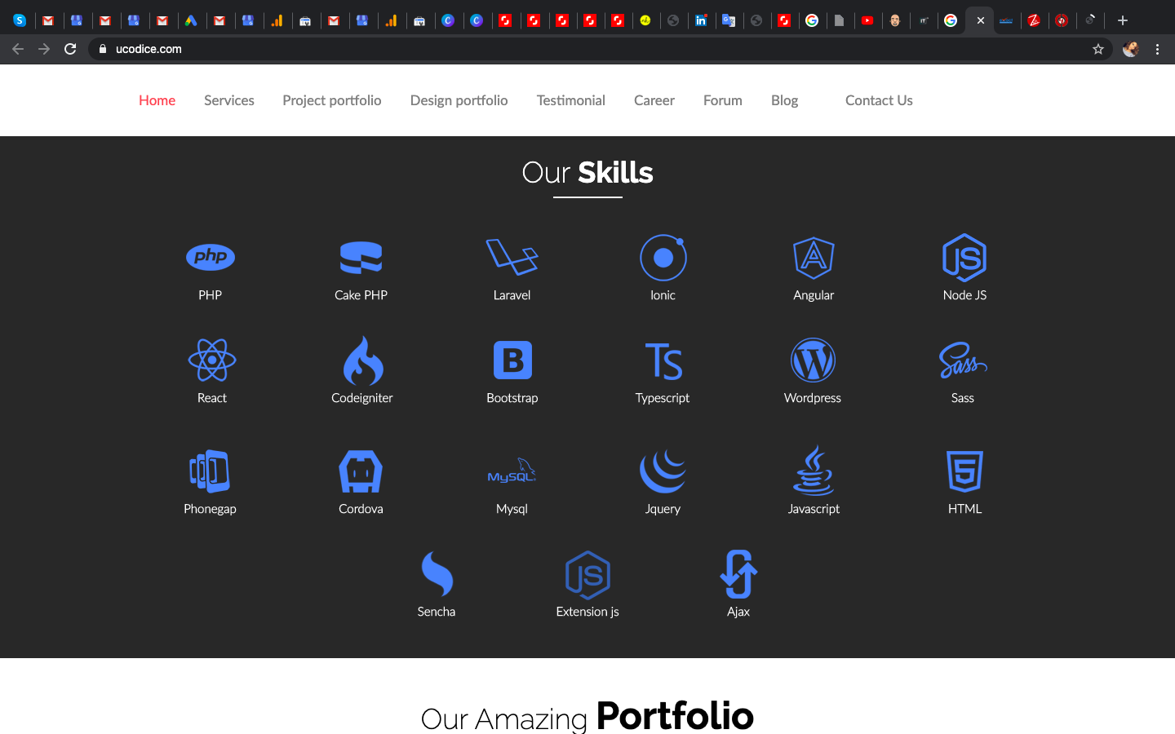

## **H3-Best IT solution at affordable rates-H3**

Take it easy because our services are never expensive. You are dealing with inexpensive website design and development in India.

At IT World Technologies, we serve not only the small business but also start-up as well as huge organized enterprises. So, while sharing your website requirements with us, feel free, and don’t expect the services to run out of your budget. Share every tiny detail that you want on your website so that way we may assist you better. IT World Technologies aims to deliver affordable website design in Noida Delhi to every client. When you are dealing with IT World Technologies, you get support for a lifetime whether you want to change the content of your website or anything else related to it.

**About Our Company**

IT World Technologies company was started in the year 2015 in Noida, Delhi. Over these years, we have gained so many happy and satisfied clients. Being one of the reputed website Design and Digital Marketing company Noida Delhi, IT World Technologies is a one-stop solution for your online version business AKA your website. We have a dedicated team of expert developers to serve each and every client. We take care of our client’s creative demands for their website which is why we offer various services such as responsive website designing, E-commerce website designing, SEO services, digital marketing, etc.

**Why choose us?**

* There are many website development companies in Noida Delhi India but offering basic services to your online business is just not enough. Nowadays, your website needs to grab extra attention and stand apart from the crowd due to cut-throat competition in the market. This is where IT World Technologies have gain expertise which makes us one of the best digital marketing Company in Noida Delhi NCR. Not only this, but we are also serving the clients overseas for projects related to e-commerce, digital marketing, PPC, etc. and we are well known as the best E-commerce Website Design Company In Noida Delhi as well as around the globe.
* **24*7** availability of customer support team
* Bunch of IT solution under one table
* We have dedicated team to cater to every need for your website
* Affordable services that meet your business requirements

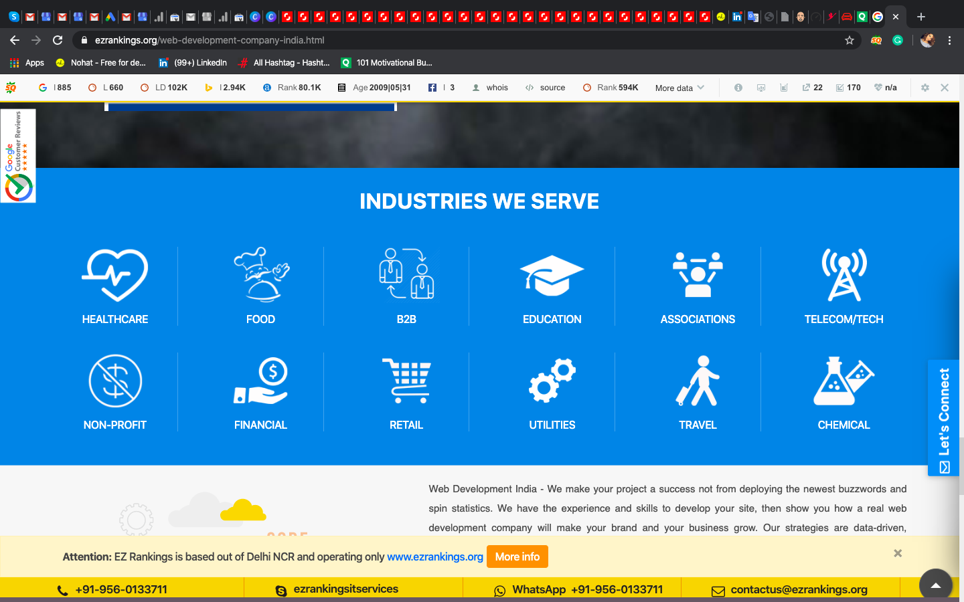

## **H4-YOU WANT TO SPREAD YOUR BUSINESS? -H4**

Having a simple business running offline is not just enough in this growing digital world. If you want recognition for your business you need to reach out to maximum potential users. This is how your business can get recognition and become a brand. Now, achieving this is not just a cupcake. It takes a lot of time and if you want the rapid growth of your business. getting a website ready for your business is the only solution. To rank up your online business, the first thing that needs to be done is to take the right step by choosing the domain and web hosting for your website. Then leave the rest of the job in our safe hands. We create a specialized website design in Noida Delhi for your business. The next step is to present your website in front of your customers or the launch of your website. Further, you need marketing of your website and you need to present an appealing website to the potential customers. This is what IT World Technologies do for you, starting from the scratch to the presentation of the website to the customers within your budget.

## H5- Do you have project and want to discuss with us? -H5

IT World Technologies is a result-driven and passionate IT Company in Noida which is based in Noida India. Our Design Strategies are based on statistics coupled with decades of experience in the realm that allow us to deliver the best results to our Global Customers. We are the Indian marketing firm serving clients all across the globe to cater the online marketing needs. If you are looking for Web Design and Development Services, Apps Development Company, and a range of Digital Marketing Services, your search ends with IT World Technologies. Discuss your projects with us and get the desired results. IT World Technologies is renowned for Domain Services, Cloud Computing, Digital Marketing, Website Development, and App Development Services. For more Info, Contact Us-

### H6- Frequently Asked Question -H6

1- What is the expected charge for a website?

Ans- The charges for designing and developing the website are affordable and within your budget depending upon the customized websites desired by the client.

2- What is the time period of developing a website?

Ans- It takes up to 1 to 4 weeks for a simple website to develop. However, the time period depends on the website requirements of the client.

3- What are the technologies that you use for website development?

Ans- IT World Technologies uses several latest and updated technologies for website development such as PHP, CSS, Ajax, HTML, Joomla, Magento, Laravel, etc.

4- How can I buy a domain and hosting for my website?

Ans- You, don’t need to freak out because IT World Technologies is here to assist you with the best domain and web hosting services.

5- How do you create a website in CMS?

Ans- WordPress is known to be the best CMS management technology. Therefore, IT World Technologies uses it to provide the best services to clients.

6- Do you provide insight into the website development process for my website?

Ans- Yes, we do provide insight to let you know how your website is doing.

7- What is the role of SEO in my business?

Ans- SEO stands for search engine optimization that attracts organic traffic to your website and helps to rank your website higher on search engine results.

8- What is the need to hire an SEO company?

Ans- A professional SEO company can plan an appropriate SEO strategy for your business. So, it is a win-win condition for you.

9- Is there any option to redesign the website?

Ans- Yes, if you find any need to change anything or edit something on your website then you can surely contact us and feel free to get the service amended.

10- Do you provide support services after the website development is complete?

Ans- Yes, we provide free website maintenance for ONE month after the project is complete. This includes Adding, Deleting, and Modifying text only.

11- Can you help in redesigning my existing website design?

Ans- Yes, IT World Technologies provides website redesigning services to its clients who need to change the appearance of their website. We find out the flaws, if any, with your current website and make the necessary changes as per your requirements, demands, and expectations.

12- Can you write content for my website?

Ans- Yes, IT World Technologies provide fresh, unique, and attractive content Writing services to the clients according to the website and the services or products offered therein.

13- What about the history of IT World Technologies?

Ans-  IT World Technologies company was started in the year 2015 in Noida, Delhi. Over these years, we have gained so many happy and satisfied clients. Being one of the reputed w**ebsite Design and Digital Marketing company Noida Delhi,** IT World Technologies is a one-stop solution for your online version business AKA your website. We have a dedicated team of expert developers to serve each and every client. We take care of our client’s creative demands for their website which is why we offer various services such as responsive website designing, E-commerce website designing, SEO services, digital marketing, etc. IT World Technologies operates not only in India but also across the world.

---------------------------------------------------------------------------------------------------------------------------------------------------------

Title- Website Design Company Noida, Digital Marketing Company Noida - IT World Technologies

Dec- IT World Technologies is a professional **web design** and development **company** based in **Noida**, Delhi NCR, India, also expertise in mobile app development (for Android, IOS & Window), Digital Marketing (SEO, SMO, PPC) and custom software development services.

**Keywords- website design company in Noida, Website design and development in Noida India, digital marketing Services in Noida** **Delhi NCR, responsive website design company in Noida Delhi**, **affordable price website design in Noida Delhi**, **best digital marketing Company in Noida Delhi NCR, E-commerce Website Design Company in Noida Delhi,**